Computer-assisted translation systems: peculiarities of their usage as tools for working on a linguistic product
Kateryna Lishnievska ¹, Iryna Karamysheva²
- Department of Applied Linguistics, Lviv Polytechnic National University, UKRAINE, Lviv, 5 Mytropolyt Andrei Street, E-mail: k.lishnievska@gmail.com
- Department of Applied Linguistics, Lviv Polytechnic National University, UKRAINE, Lviv, 5 Mytropolyt Andrei Street, E-mail: iryn_ka@ukr.net
Abstract – This article is devoted to the research of the usage of computer-assisted translation systems SDL TRADOS Studio 2017 and MemoQ Translator Pro 2017 as tools for translating a linguistic product. The concepts of project and terminology management systems, translation memory and translation quality assurance are clarified in this article.
Keywords – computer-assisted translation, computer-assisted translation tool, project management, translation memory, terminology management, translation quality assurance.
Introduction
In the 21st century, text translation without the use of special programs can be compared to the typing on a typewriter. Nowadays, a large number of computer-assisted translation systems have been developed. Therefore, the translator can use these systems in the process of translation. With the use of computer-assisted translation systems, a skilled translator is able to perform high-quality, high-volume translation in a short period of time.
Today, there are many software products that translators can use. Some software products are more functional, but they are very expensive, other products are less functional, but their cost is also much lower, some of them are free of charge. The main task of all computer-assisted translation tools is to help the translator to perform a qualitative and professional translation of a specific linguistic product.
The users of such systems are competent translators. The translator has access to terminology in several languages and translation memory. It is important that during the work with such software products the translator is able to manage translation projects, the multilingual terminological base as well as the common translation memory which stores all the previous translation segments.
Due to their functionality, computer-assisted translation systems become an indispensable tool for translators. In addition, they help to save the time of a translator and guarantee a high-quality translation. Therefore, these tools are in demand on the market of application software programs.
The computer-assisted translation tools play an important role because choosing the optimal settings in such a program makes the translation process more convenient. Therefore, it is quite expectedly that the problem of performing professional and high-quality translation with the help of computer-assisted tools attracts the attention and interest not only of experts in the IT-industry, but also of linguists, who study the problems of these systems’ functioning, in particular: J. Russell [9], R. Kohn [9], O.V. Skvortsova [11], E.V. Tykhonova [11], N.S. Zverieva [12], M.A. Mosiienko [8], U.S. Baimuratov [2], T. Grado [4], M. Linder [6].
In recent years, there has been an increasing number of researchers, who are interested in the features of computer-assisted translation systems, which serves as the evidence of the studied issue topicality. Among the latest ones: “Yspolzovanye ynformatsyonnykh tekhnolohyi dlia optymyzatsyy protsessa perevoda” [Usage of information technology for optimization of the translation process] (E.A. Morozkina and N.R. Shakirovа, 2012 [10]); “Yspolzovanye system klassa “Translation memory” v perevodcheskoi deiatelnosty” [The usage of systems of the class "Translation memory" in translation practice] (A.O. Arestova, 2016 [1]); “Pamiat perevodov kak sredstvo povyshenyia proyzvodytelnosty perevodchuka” [Translation memory as a resource for increasing of translator productivity] (Y. R. Chemezov, 2017 [3]); “Systemy avtomatyzatsii perekladu vilnoho typu yak skladova pidhotovky maibutnikh perekadachiv” [Free-type computer-assisted translation systems as a component of future translators training] (K.O. Kyrychek, 2018 [5]).
The purpose of this article is to explore the main features of the computer-assisted translation systems SDL Trados Studio 2017 and MemoQ Translator Pro 2017.
SDL Trados Studio 2017 is a leading translation and editing software that also includes project management, terminology management and translation memory technology.
SDL Trados Studio 2017 has a project management system. One project may contain from one to several files which can be translated into one or more languages. By creating a specific project, the project manager should control the progress of its execution with the help of certain project management tools which are offered in the computer-assisted translation tool SDL Trados Studio 2017.
Such tools include the system of automated project creation, preliminary translation of project files with the help of translation memory, analysis of data files for translation during the project creation, tracking of the translation process, creation of packages that contain translated files.
The above tools can be found in the sections: "Projects", "Files", "Reports". Thus, project management tools help the project manager to automate the project creation process, manage project data and monitor the project workflow.
MemoQ Translator Pro 2017 is a complete environment for translating and localizing linguistic products that also has a translation editor, termbase, LiveDocs and translation memory.
The basic principle of project management in MemoQ Translator Pro 2017 is quite similar to the computer-assisted translation system SDL TRADOS Studio 2017. The computer-assisted translation system MemoQ Translator Pro 2017 also gives the ability to create and manage projects. You can add a large number of files to one project, which can be translated into one or more languages. The project manager has not only the ability to create projects and control the process of working on a particular project, but also to change translation memory and other project resources, create and edit project templates. The process of creating and editing filter configurations and segmentation rules is of importance as well which can improve the work of the automated quality assurance component [7, р.27].
At the same time, the project manager has access to inactive projects and can also generate automatic reports that contain information about the translated files. All actions, which are related to project management, can be done in the section "Project".
While working on certain projects, the translator has the ability to use the technology of Translation memory. Both computer-assisted translation tools SDL TRADOS Studio 2017 and MemoQ Translator Pro 2017 offer this functionality to their users.
Translation memory is a database that stores entire paragraphs, sentences or segments of text that have been previously translated with the help of computer-assisted translation system.
Computer-assisted translation systems SDL TRADOS Studio 2017 and MemoQ Translator Pro 2017 offer translation of the certain segment automatically, if they find in the translation memory identical (Exact matches), partial (Fuzzy matches) or 100% context matches (Perfect matches) with a new document. The translation memory system contains the original language text and its translation.
It should be noted that both systems have the function "Alignment". Text alignment is one of many ways of using previous translations. With the help of the function "Alignment", the previously translated texts can be converted into translation units that will be added to the translation memory. Text Alignment tool helps to put together the corresponding segments of the source and target languages of a specific text.
The materials for the research of the efficiency of the computer-assisted translation systems are English-language instruction manuals of household appliances that should be translated into the Ukrainian language.
It is advisable to use translation memory by translation of similar technical texts, especially with regard to the instruction manuals for household appliances. It is worth considering some examples of using translation memory technology in SDL TRADOS Studio 2017 and MemoQ Translator Pro 2017.
Almost every instruction has the following sentence: Read all instructions before using this appliance. This means that it is enough to translate this sentence once, and then the translation memory will automatically offer its translation: Прочитайте всі інструкції перед тим, як користуватися цим приладом. The computer-assisted translation system defines this phenomenon as an exact match.
By translation of instruction manuals for washing machines, you can also find context matches (Perfect matches). Two different instructions contain the following sentences: Packaging materials may be dangerous for children and Packaging materials can be dangerous for children. The computer-assisted translation system will offer a translation of this sentence, which the translation memory already has, namely: Пакувальні матеріали можуть бути небезпечними для дітей.
Fuzzy matches are also not uncommon by translation. As an example, we can consider these two sentences: Use child lock to prevent children from intervening with the product and Use Child Lock function to prevent children from tampering with the machine. Inaccurate matches represent 70% segment similarity. Therefore, the computer-assisted translation system may offer a translation that is already available in translation memory – Використовуйте дитячий замок, щоб запобігти втручанню дітей в роботу пристрою, but it should be corrected as follows: Використовуйте функцію «Блокування доступу для дітей», щоб запобігти втручанню дітей в роботу пральної машини.

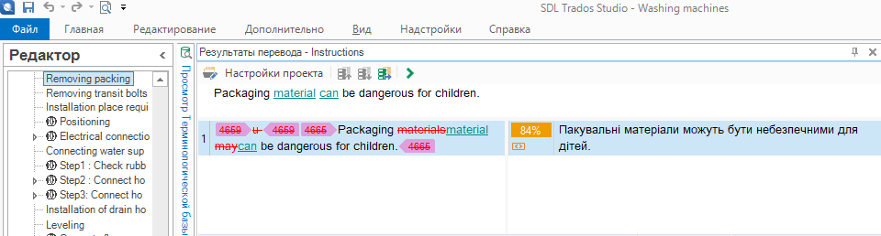
Fig.1. Working with SDL TRADOS Studio 2017
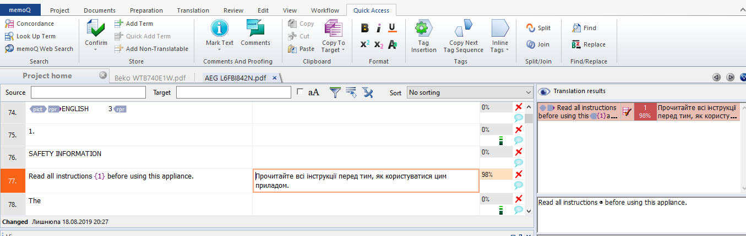
Fig.2. Working with MemoQ Translator Pro 2017
Figs.1 and 2 represent the process of using translation memory in such environments as SDL TRADOS Studio 2017 and MemoQ Translator Pro 2017 during translation of instruction manuals for household appliances.
Thus, translation memory simplifies the translation process, significantly improving the quality, speed, consistency and efficiency of each translation task.
The use of Terminology management systems is considered as efficient tools for translation of instruction manuals for household appliances. Terminology management systems allow achieving efficient and accurate translation by arranging terminology with a clear set of rules for its use. Term bases are used for terminology regulation. Term bases are searchable databases that contain a list of approved terms.
In addition to the computer-assisted translation system SDL TRADOS Studio 2017, there is SDL Multiterm 2017 on the software market, which is a separate terminology management system. The main principle of this system is that it is the centre of specialized terminology and provides uniformity and high-quality content, from the stage of preparation of the source text to the completion of translation.
SDL MultiTerm uses a semantic approach to terminology management. One glossary contains all the terms that relate to one concept, as well as the descriptive and classification information. This approach allows you to create multilingual terminology bases and to reflect the life cycle of a term in a dictionary article: current or outdated, recommended or unwanted, etc., which greatly simplifies the choice of the correct term.
In its turn, MemoQ Translator Pro 2017 has a Qterm component, which is a part of the software responsible for terminology management and is used to store the specialized terminology for translation.
Key features of this component are adding terms to the terminology database with one click, availability of information about a specific term and its definition, availability of term statuses (recommended, forbidden), storing terms with the addition of relevant images, the function of removing terms from the terminology database.
It is also advisable to use terminology management systems by translation of technical texts. English instruction manuals for dishwashers often have specialized terms that should be added to the terminology immediately, such as:
- Term: detergent dispenser;
Translation: резервуар для миючого засобу;
Definition: one that dispenses or gives out, especially a machine or container that allows the contents to be removed and used in convenient or prescribed amounts.
Term status: recommended.
- Term: rinse aid;
Translation: споліскувач;
Definition: cleaning product said to improve finish of items.
Note: only for dishwashers.
Term status: recommended.
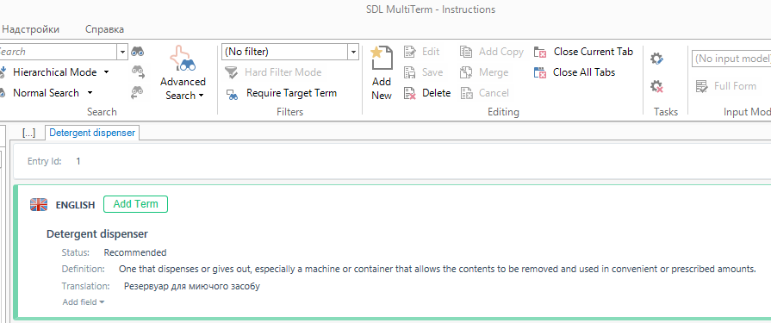
Fig.3. Working with SDL Multiterm 2017
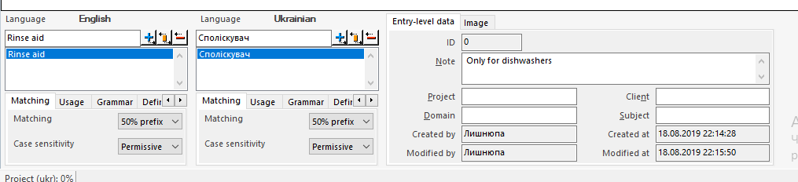
Fig.4. Working with the component – Qterm
Figs.3 and 4 illustrate the process of using the terminology base by working with the SDL Multiterm 2017 and Qterm terminology management systems when translating instruction manuals for household appliances.
As a consequence, terminology management systems help the translator to not only shorten the time to select appropriate specialized terms by translation of technical texts, but also to make better and more consistent translations.
The last, but not least important aspect by working with computer-assisted translation tools is the automated quality assurance module of the produced translation. The translation quality assurance system is developed to support the translator.
The automated quality assurance identifies errors, the types of which depend on the configuration of the computer-assisted translation system. All project settings are usually set by default; the translator can change them according to the project’s tasks.
An important element of the computer-assisted translation system SDL Trados Studio 2017 is the module "quality assurance". This module can be found in the settings of the project by clicking on the tab "File". The QA system consists of QA Checker 3.0 components, tags and terminology.
QA Checker 3.0 allows the translator to check the translated document for any inconsistencies or errors. The check is conducted by the following criteria: segment check, segment exclusion, consistency check, punctuation check, number check, check of the word list, check of regular expressions, trademark check, check of segment length.
The function "quality assurance" also includes a check of the tags. With the help of the function "quality assurance", the translator can check the correctness of the tags, which are used in the original and translation texts. The option of tag check allows the translator to check added tags, deleted tags, the order of tags, invisible tags and spaces between tags. During the checking process, you can ignore the formatting tags, the blocked segments and the difference between a normal and continuous space.
Another important component of quality assurance is the parameter "terminology check". The system checks the document for the use of prohibited terms and the presence of untranslated terms.
In the computer-assisted translation system MemoQ Translator Pro 2017, the function of quality control is implemented at two levels: "quality control settings" and "quality assurance."
The parameter "quality control settings" checks for the following criteria: segments and terms, consistency, numbers, punctuation, spaces, capital letters, embedded tags, segment length and regular expressions.
The "quality assurance" parameter allows you to start checking the quality of documents and translation memory. In this case, it is possible to remove the warnings after the quality check and export the quality check report. It also eliminates errors and warnings.
The function of quality assurance in computer-assisted translation systems SDL Trados Studio 2017 and MemoQ Translator Pro 2017 also identify the so-called "non-linguistic errors", which usually take a long time to be found and corrected in the text. Such errors include unnecessary or missing spaces, missing or inconsistent tags, spelling errors, untranslated text segments and others. The quality control system does not correct errors automatically, but their identification and error navigation capabilities allow a specialist to quickly correct such errors.
In general, translators often need to translate large texts. In addition, the translator should check the text for the presence of different types of mistakes in it. Quality assurance is the best way to check the translated text for errors quickly and accurately.
Nowadays, automated quality assurance systems have become a reliable assistant for both translators and proofreaders, without them it is much more difficult to create a high-quality and complete translation.
Conclusion
The article defines the main features of the computer-assisted translation systems SDL Trados Studio 2017 and MemoQ Translator Pro 2017, namely the principle of project management systems, translation memory technology, terminology management systems and the principle of automated quality assurance of a linguistic product.
The computer-assisted translation tools SDL Trados Studio 2017 and MemoQ Translator Pro 2017 have project management systems, which help to automate the project creation process, manage project data and control the project workflow.
By working on certain projects, the translator has the ability to use Translation memory, a database that stores entire paragraphs, sentences or segments of text that were previously translated with the help of computer-assisted translation system. Both SDL TRADOS Studio 2017 and MemoQ Translator Pro 2017 offer their users such functionality that, in turn, saves the time of a translator and the translation process becomes easier.
Terminology management systems, namely SDL Multiterm 2017 and Qterm, can be also considered as translation tools. Term bases are used for the regulation of terminology, they are searchable databases that contain a list of approved terms and a clear set of rules for their use. Terminology management systems simplify the process of selecting appropriate specialized terms during the translation process.
To check the quality of the translation, the translator needs to use the automated quality assurance module, which both computer-assisted translation systems SDL TRADOS Studio 2017 and MemoQ Translator Pro 2017 contain. The quality assurance system consists of components that actually check the quality of text, tags and terminology.
The computer-assisted translation systems have become a necessary tool for the modern translator. Working with such systems helps to save the time of the translator and make qualitative and professional translation, so it is perspective to study the features of their use for translation of texts that belong to different functional styles.
References:
[1] Arestova A.O. (2016). Yspolzovanye system klassa “Translation memory” v perevodcheskoi deiatelnosty [The usage of systems of the class "Translation memory" in translation practice].
[2] Baimuratov U.S. (2013). Elektronnyi ynstrumentarui perevodchuka [Electronic toolkit for translator], 140.
[3] Chemezov, Y. R. (2017). Pamiat perevodov kak sredstvo povyshenyia proyzvodytelnosty perevodchuka [Translation memory as a resource for increasing of translator productivity].
[4] Grado T. (2014). Free CAT tools as an alternative to commercial Software. Soria: Universidad de Valladolid, 74.
[5] Kyrychek K. O. (2018). Systemy avtomatyzatsii perekladu vilnoho typu yak skladova pidhotovky maibutnikh perekladachiv [Free-type computer-assisted translation systems as a component of future translators training].
[6] Linder M. (2015). SDL Trados Studio 2015. SDL Group, 457.
[7] MemoQ LNG User Guide. (2014). MemoQ Group, 49.
[8] Mosiienko M.A. (2006). Avtomatyzyrovannyi perevod ustarevshykh prylozhenyi na novye yazyky y platformy [Computer-assisted translation of out-dated applications into new languages and platforms], 15.
[9] Russell D., Con.R. (2013). Avtomatyzyrovannyi perevod [Computer-assisted translation], 105.
[10] Shakirova N.R., Morozkina E.A. (2012). Yspolzovanye ynformatsyonnykh tekhnolohyi dlia optymyzatsyy protsessa perevoda [Usage of information technology for optimization of the translation process].
[11] Skvortsova O.V., Tykhonova E.V. (2013). Problemy y preymushchestva avtomatyzyrovannoho y mashynnoho perevodov [Problems and advantages of computer-assisted and machine translations], 1287–1289.
[12] Zvierieva N.S. (2008). Aktualnost yspolzovanyia avtomatyzyrovannykh system perevoda [The relevance of the use of computer-assisted translation systems], 1–4.

