Forest roads restoration with biodiversity conservation using GIS
Kharchenko Anna¹, Khrutba Viktoriia¹, Trofymenko Petro², Stakhiv Iryna², Liashenko Dmytro².

Abstract
The paper focuses on GIS use for the restoration of forest roads while considering biodiversity conservation. It addresses the challenges posed by road infrastructure in forest ecosystems, emphasizing the negative ecological impacts caused by roads. The research highlights the importance of integrating ecological data and infrastructure planning to achieve sustainable development of the territory. The authors present survey results from the roundtable discussion "Social Dialogue. Environmental Impact Assessment (EIA) in Ukraine" and propose the algorithm of the electronic calculator for environmental impact assessment digitization.

¹ National Transport University, M. Omelyanovicha-Pavlenka Str., 1, Kyiv, 01010, Ukraine
² Kyiv National University of Taras Shevchenko, Vasylkivska Str., 90, Kyiv, 03022, Ukraine

Introduction
Nowadays, the enormous pressure on forest ecosystems due to human activities (logging, wildfires, war in Ukraine), has emphasised the need for strategies to restore forest areas. Forest roads, while essential for various purposes such as logging and recreation, can also significantly impact ecosystem health if not properly planned. GIS (Geographic Information Systems) are a powerful tool for the sustainable management of forest roads while considering the preservation of biodiversity (Liashenko, et al., 2021). By integrating spatial data (GIS)-based analytic tools enables ecologists to make best geodesign of a territory and to help explore alternative future development scenarios (Orland & Steinitz, 2019). GIS helps in assessing the potential impact of road development on wildlife corridors, guiding decisions that balance human needs with the conservation of natural habitats. Counteraction of the forest crisis, forest and landscape management should aim to reduce fragmentation and maintain tree biomass and forest cover in the landscape. Increasing the size of continuous forest fragments contributes to ecosystem-based adaptation to climate change (Mann et al., 2023).

Theory

The paper deals with development of a methodology for determining animal migration routes for territory defragmentation using GIS and digitalization of environmental impact assessment (EIA) for construction and reconstruction projects of forest roads. According to the "Recovery Plan for Ukraine" by the National Council for Recovery of Ukraine from the Consequences of the Russian – Ukrainian War, there are plans to carry out the reconstruction of the transportation infrastructure damaged by the war in the coming years (Recovery Plan, 2023). The plan includes several priority directions, one of which is the reconstruction of the transportation infrastructure while considering the need to restore Ukraine's wild areas.
By connecting cities and villages, the road infrastructure supports the socio-economic development of a territory, offering significant benefits for the well being of citizens. These benefits include improved connectivity between populated areas and communities, increased employment opportunities, reduced transportation costs, better logistics, and rural development. However, road infrastructure also presents numerous threats and negative problems to ecosystems, such as environmental pollution, loss of biodiversity, depletion of natural resources, deforestation, and the acceleration of climate change.
The expansion of transportation infrastructure facilities leads to forced fragmentation of the territory, worsening local ecosystems through the disruption of natural connections for wildlife. This issue is particularly critical in forest ecosystems, where forest roads and man-made structures virtually intersect with the wilderness. In studies (Pagany, 2020; Medrano-Vizcaíno, 2023), factors causing secondary negative effects from the omission of wildlife migration routes are also highlighted in the design of infrastructure projects in forest ecosystems. These factors include the inevitable presence of wildlife on the road surface, often resulting in severe road accidents. According to the research findings (Pagany, 2020; Graf, 2019; Mulero-Pázmány, 2022), the proximity of roads to forests is a significant factor. Currently, there are no specific methodologies, in Ukraine, for considering animal migration routes in the design of road and transportation infrastructure restoration projects. This makes the present study relevant.
Roads increasingly fragment forests as naturally continuous ecosystems into smaller fragments more or less isolated from each other (Mann et al., 2023), leading to fragmentation and displacing plant and animal species, risking their genetic diversity and disappearance. Road traffic contributes to forest pollution by emitting exhaust fumes, oil spills, fuel, or toxic substances. Changes in the hydrological regime caused by road structures disrupt natural waterways, causing flooding in some areas and drought in others. There are many other examples of road impacts on forest ecosystems that are well known to ecologists but not well understood by engineers and road planners. This knowledge gap usually doesn't affect road and highway quality but can lead to mistakes in decision-making, problem-solving, task execution, as well as inefficiency, inaccuracies, and suboptimal results in construction and reconstruction planning from an ecological safety perspective. On the other hand, a comprehensive understanding of threats, risks, and consequences in road design, construction, or reconstruction is a key preventative approach to biodiversity protection, addressing climate change impacts, while ensuring that forest ecosystems provide goods and services alongside improved sustainable forest management.
In Ukraine, legislation acts have been adopted that require Environmental Impact Assessment (EIA) for projects in various sectors, including road construction and reconstruction projects (State Standard of Ukraine 9060, 2020; State Standard of Ukraine 9061, 2020). EIA helps identify and assess the potential impact of these projects on the environment, along with a systematic evaluation of factors such as air and noise pollution, habitat destruction, water pollution, and socio-economic consequences, to make informed decisions and develop relevant mitigation measures to counteract anthropogenic impacts. The EIA ensures compliance with legal requirements and helps prevent unauthorised or poorly planned road construction and reconstruction projects by detecting potential environmental issues at an early stage.
A modern approach to collecting data on landscapes, infrastructure and territorial delineation involves the use of remote sensing (in particular unmanned aerial vehicles). However, the data collected will require proper processing, for which a methodology for territory defragmentation using GIS technologies needs to be developed as a tool to collect data on biodiversity in forest ecosystems. Implementing such a project requires licensed GIS software, unmanned aerial vehicles, and mathematical methods for database processing. The results of developing a methodology for territory defragmentation using GIS for enhancing road safety will have practical significance as they enable project management personnel in design organisations to make well-founded managerial decisions regarding road network expansion while considering the needs for restoring Ukraine's wildlife.
The work is based on researching legislation acts, methodological support for the assessment of animal migration routes, inventory of fragmented territories, identifying discrepancies in existing infrastructure with ecosystem conservation requirements, and conducting field studies using unmanned aerial vehicles in conjunction with GIS data processing. Processing these results and generating a map is going to enable the development of recommendations for bearing in mind animal migration routes in road design for the infrastructure sector.
Another challenge for the restoration of transportation infrastructure in forest ecosystems is that despite legislative acts and developed EIA methodologies for road construction and reconstruction projects, there is still no ready-to-use digital tool with comprehensive information about various environmental impacts and their consequences (Mateichyk, 2019). This tool should be easily accessible to road engineers involved in the planning, design, and construction of roads to optimise processes and improve the accuracy of identifying threats to the environment and society, thus increasing overall project efficiency. Furthermore, traditional approaches to EIA are typically time-consuming and expensive and with a high risk of human error (Khruhtba, 2022).

Results
In 2021, a roundtable discussion on "Social Dialogue. Environmental Impact Assessment (EIA) in Ukraine" took place, involving 70 respondents regarding EIA for transportation projects (Figure 1).
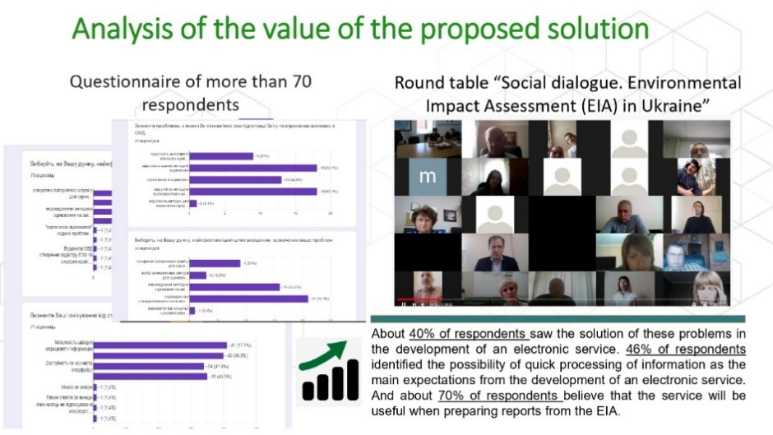
Figure 1. Analysis of respondents' survey results from the roundtable discussion "Social Dialogue. Environmental Impact Assessment (EIA) in Ukraine."

Approximately 40% of the respondents indicated that most gaps can be addressed through the use of a digital tool. This tool should be an intuitively understandable electronic service with easy accessibility for road engineers, ecological experts, consultants, and 46% of the respondents noted that such a digital tool should aid in data manipulation processing. Lastly, around 70% of the respondents speculated that such a service would be beneficial for preparing environmental impact assessment reports and engaging with stakeholders. Furthermore, groups of key stakeholders interested in the development of such a service were identified (Figure 2).
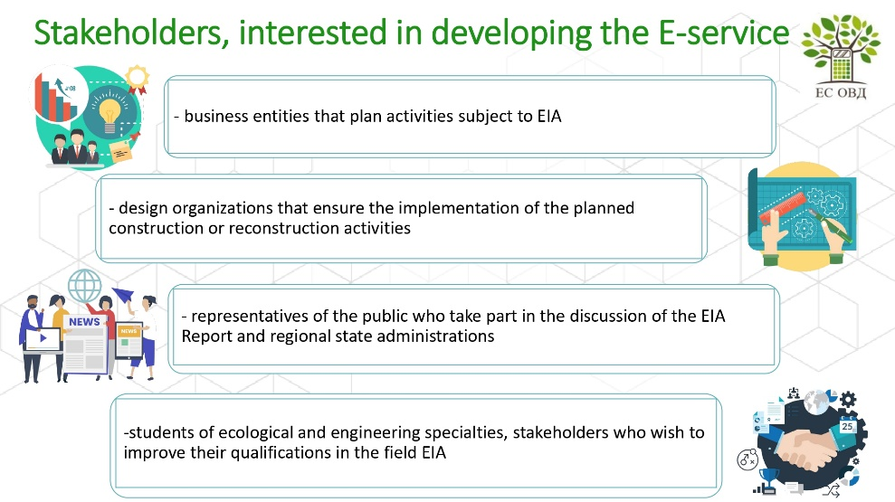
Figure 2 Main stakeholders interested in the development of the prototype of the digital environmental impact assessment tool

Thus, the research tasks include collecting basic environmental data, identifying and assessing environmental threats and risks, developing principles of sustainable development, creating a model of social, environmental, and economic security, conceptualizing the EIA method and criteria, and developing a prototype of the digital tool (Figure 3).

Figure 3 Stages of digital tool prototype development (EC EIA - electronic calculator for environmental impact assessment digitization)
Conclusions

Incorporating GIS into forest road restoration projects not only helps optimise road layouts, but also provides valuable information on long-term environmental impacts. It allows for informed decision-making, helping to strike a balance between economic development and the preservation of biodiversity. As we face ongoing challenges in sustaining our natural resources, embracing GIS technologies in the management of forest road networks holds immense promise for maintaining the health and resilience of forest ecosystems.
The practical importance of the electronic calculator lies in its ability to enable the project organisations' management personnel to make informed managerial decisions about the development of road networks within forests, taking into account the need for restoration of ecosystems and preservation of the environment, including the wild nature of Ukraine.
Furthermore, it is proposed to develop a methodology that will serve as a decision-making tool for the design of infrastructure projects and their elements. This methodology should be implemented in the field as recommendations for considering animal migration pathways in the design of highways, using GIS technologies.

References

Graf, S.; Pagany, R.; Dorner, W. and Weigold, A. (2019). Georeferencing of Road Infrastructure from Photographs using Computer Vision and Deep Learning for Road Safety Applications. In Proceedings of the 5th International Conference on Geographical Information Systems Theory, Applications and Management - GISTAM; SciTePress, pages 71-76. DOI: 10.5220/0007706800710076
Khrutba, V., Kharchenko, A., Khrutba, Y., Kolbasin, M., Tsybulskyi, V., Silantieva, I., & Lysak, R. (2022). Applying a design mindset to develop a prototype of an electronic service for assessing the impact on the environment. Eastern-European Journal of Enterprise Technologies, 4(2(118), 6–15. https://doi.org/10.15587/1729-4061.2022.262356
Liashenko, D., Boiko, O., Nikitchenko, Y., Koper, N., & Bashutska, U. (2021, November). Geoinformation support of forest management for sustainable development of the Carpathian region. In 15th International Conference Monitoring of Geological Processes and Ecological Condition of the Environment (Vol. 2021, No. 1, pp. 1-5). European Association of Geoscientists & Engineers. https://doi.org/10.3997/2214-4609.20215K2052
Mann, D., Gohr, C., Blumröder, J. S., & Ibisch, P. L. (2023). Does fragmentation contribute to the forest crisis in Germany?. Frontiers in Forests and Global Change, 6, 1099460.
Mateichyk, V., Khrutba, V., Kharchenko, A., Khrutba, Y., Protsyka, O., Silantieva, Y. (2019). Developing a Tool for Environmental Impact Assessment of Planned Activities and Transport Infrastructure Facilities. TRANSCOM 2021: 14th International scientific conference on sustainable, modern and safe transport. Published by Elsevier B.V. https://doi.org/10.1016/j.trpro.2021.07.185
Medrano-Vizcaíno P, Grilo C, González-Suárez M (2023) Research and conservation priorities to protect wildlife from collisions with vehicles. Biol Conserv 280:109952. https://doi.org/10.1016/j.biocon.2023.109952
Mulero-Pázmány M, Sullivan T, Rollán CL et al (2022) Road orientation affects the impact of roads on wildlife. Wildl Res. https://doi.org/10.1071/WR21149
Orland, B., & Steinitz, C. (2019). Improving our Global Infrastructure: The International Geodesign Collaboration. Journal of Digital Landscape Architecture, 4, 213-219.
Pagany R. (2020). Wildlife-vehicle collisions - Influencing factors, data collection and research methods. Biological Conservation 251(5). September 2020. DOI: 10.1016/j.biocon.2020.108758
State Standard of Ukraine 9060 (2020). DSTU 9060:2020 Otsinka vplyvu na dovkillia. Transportni sporudy. Kryterii otsinky ta pokaznyky vplyvu na dovkillia. [Environmental impact assessment. Transport facilities. Assessment criteria and environmental impact indicators]. Kyiv. [in Ukrainian].
State Standard of Ukraine 9061 (2020). DSTU 9061:2020 Otsinka vplyvu na dovkillia. Transportni sporudy. Nastanova shchodo pidhotuvannia zvitu z otsinky vplyvu na dovkillia. [Environmental impact assessment. Vehicles. Methodological recommendations for drawing up an environmental impact assessment report]. Kyiv. [in Ukrainian].
Ukraine recovery plan (2023). The National Council for the Recovery of Ukraine from the Consequences of the War in Ukraine. URL: https://recovery.gov.ua/. [in Ukrainian].

