GeoTerrace-2026-XXX

Monitoring glacier dynamics using Copernicus data
*D. Kukhtar (Lviv Polytechnic National University) K. Tretyak (Lviv Polytechnic National University)
SUMMARY

Understanding the dynamics of glacier discharge is essential for assessing the contribution of the Antarctic Ice Sheet to global sea-level rise. This study aims to model the relationship between glacier velocity and meteorological conditions, particularly air temperature and precipitation, for glaciers located on the Kyiv Peninsula in West Antarctica. To achieve this objective, Earth observation and climate reanalysis products provided by the Copernicus Programme were integrated, including Sentinel-1 synthetic aperture radar (SAR) imagery and ERA5 reanalysis data. In addition, time series of meteorological observations from the Akademik Vernadsky Station were used. Glacier velocity was derived from Sentinel-1 SAR imagery using the Offset Tracking method. ERA5 provides hourly estimates of a wide range of atmospheric and surface variables, including air temperature and precipitation. Data covering the period from May 2015 to November 2022 were used to establish a functional relationship between meteorological conditions and glacier velocity. The practical significance of the results lies in the potential to forecast glacier motion using spatially distributed meteorological information and to improve the assessment of ice discharge from the Antarctic Ice Sheet.
Keywords: Ice velocity, SAR, Trooz glacier, Sentinel, ERA5 Reanalysis, UAS Akademik Vernadsky.

Corresponding Author: denys.v.kukhtar@lpnu.ua

Introduction

In the modern world, climate change is one of humanity's most pressing problems. These changes are felt in all parts of the planet: from rising sea levels and extreme weather events to changes in ecosystems and biodiversity. Effective monitoring and understanding of these processes requires high-quality data covering various territories and aspects of natural and anthropogenic factors.
The Copernicus program, initiated by the European Union, is one of the largest Earth monitoring initiatives, providing unprecedented opportunities for climate change research. Due to its Sentinel satellites and other components, Copernicus provides a continuous stream of data that is critical for analyzing and predicting climate change at the global level. This program plays a key role in supporting international efforts to combat climate change by providing data for scientific research and practical solutions.
The Copernicus program plays one of the leading roles in the study of Antarctic glaciers, which are sensitive indicators of climate change on the planet. The main tool in these studies is the constellation of Sentinel satellites, which provide a systematic collection of data from different components of the Earth system. These data allow scientists to monitor changes in the ice cover of Antarctica, measure the rate of melting of glaciers, and also analyze the impact of climate change on the continent as a whole. Through regular monitoring, Copernicus helps identify trends that indicate accelerated melting of glaciers, which has important implications for global sea levels (Cook et al., 2014).
This article presents the application of data and products of the Copernicus Programme for assessing the dynamics of glaciers. The study focuses on glaciers located on the Kyiv Peninsula in West Antarctica, with particular attention given to Trooz Glacier. Trooz Glacier is the largest glacier on the peninsula extending over 28 km in length. Satellite-derived glacier velocity data and meteorological data from the Copernicus Climate Change Service were integrated to investigate the spatial and temporal variability of glacier motion and its relationship with atmospheric conditions.

Method and Data

The high spatiotemporal resolution of SAR data, with a 12-day interval between acquisitions, enables the generation of consistent maps for analyzing glacier velocities over extended periods. Another important component of glacier dynamics assessment is information on environmental factors, particularly meteorological parameters.
In (Tretyak & Kukhtar, 2023), a model of Trooz Glacier velocity (65°20′S, 63°58′W) was developed based on glacier velocity data from 2015 to 2022 and air temperature data. The study used air temperature data over the glacier surface obtained from the earth.nullschool.net resource, together with in situ temperature measurements collected at the Ukrainian Antarctic Station Akademik Vernadsky, located on Galindez Island, approximately 20 km from the glacier terminus.
The present study aims to develop a more comprehensive model covering the entire area of Trooz Glacier. Such a model would make it possible to predict glacier velocity at any point across the glacier under specified meteorological conditions (Figure 1).

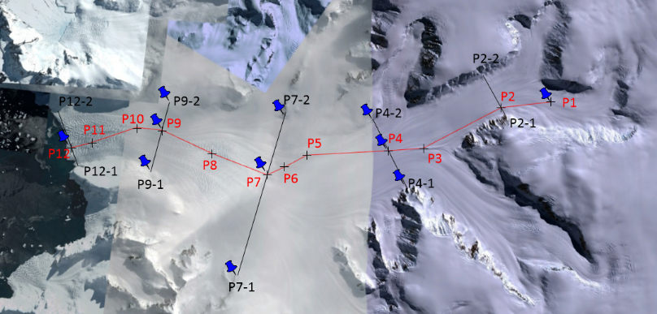
Figure 1. Trooz glacier with control points for complex model development. Each control point integrate input data: ice flow velocity, air temperature, precipitation.
In addition to air temperature, the model should account for precipitation, which can also have a significant effect on glacier velocity (Kadurin & Kadurin, 2023). As in the previous study (Tretyak & Kukhtar, 2023), precipitation and air temperature over the glacier surface will be estimated based on in situ measurements conducted continuously at the Akademik Vernadsky Station. Reliable relationships between these parameters can be established by analyzing long-term observations in combination with meteorological model and reanalysis data to estimate meteorological conditions over the glacier surface.
The earth.nullschool.net resource used in the previous study (Tretyak & Kukhtar, 2023) to obtain air temperature data is primarily intended for the visualization of weather conditions and is therefore not suitable as a source of large-scale datasets for scientific analysis. Moreover, direct access to the underlying database is not available. Therefore, there is a need to use meteorological datasets containing parameters such as air temperature and precipitation for the study area, with sufficiently high spatiotemporal resolution and a convenient format for export and further processing.
Today, a comprehensive approach to data collection and analysis makes it possible to obtain meteorological information even for areas where direct ground-based measurements are unavailable. This has become possible through the development of global meteorological models and climate reanalysis datasets that cover the entire planet. In addition to high spatial resolution, these datasets provide high temporal resolution, allowing meteorological parameters to be determined at intervals of several hours.
Climate reanalysis datasets combine observations collected over time with numerical models to provide spatially and temporally consistent estimates of atmospheric and climate variables. They have become an important source of information in geosciences, as they enable the reconstruction and analysis of climate variability over long periods and across regions where direct observations may be sparse or unavailable.
In this study, ERA5 reanalysis data were obtained from the Copernicus Climate Data Store (CDS). ERA5 is the fifth-generation global atmospheric reanalysis produced by the Copernicus Climate Change Service (C3S) in collaboration with the European Centre for Medium-Range Weather Forecasts (ECMWF). The dataset provides global coverage from January 1940 to the present and includes a wide range of atmospheric and surface variables. Compared with previous generations of reanalysis, ERA5 provides improved spatial and temporal resolution as well as enhanced representation of atmospheric processes (Gleixner et al., 2020).
The broad range of applications of ERA5 data, including climate research, weather-related studies, energy assessment, and machine learning, is complemented by their convenient availability in the netCDF format. The data were processed in a Linux environment using Climate Data Operators (CDO). CDO is a collection of command-line tools designed for the processing and analysis of climate and meteorological datasets stored in formats such as netCDF-3, netCDF-4, GRIB1, and GRIB2 (Climate Unboxed, 2021). The software provides a wide range of operations, including inspection of data and metadata, spatial subsetting of the study area, statistical analysis, horizontal regridding using methods such as nearest-neighbor, bilinear, and bicubic interpolation, and extraction of data for specified geographic coordinates.

Results

As noted above, direct measurements of meteorological parameters at the Ukrainian Antarctic Station (UAS) Akademik Vernadsky play an important role in the study of the Antarctic environment, particularly glacier dynamics.
Within the framework of this study, observations from the UAS are used to establish the relationship between air temperature measured at the station and temperature conditions over the glacier surface. These relationships, together with precipitation observations, provide the basis for estimating meteorological parameters across Trooz Glacier. Consequently, the glacier velocity model is developed using systematically collected in situ temperature and precipitation measurements from the Akademik Vernadsky Station.
At regional and global scales, meteorological observations from the Akademik Vernadsky Station complement satellite-based observations and Copernicus products, providing an integrated view of atmospheric conditions over the Antarctic Peninsula and contributing to the broader understanding of climate variability.
A comparison of air temperature and precipitation from the ERA5 reanalysis with corresponding observations from the UAS also provides an opportunity to assess the consistency of the reanalysis data for the study area. Under typical conditions, air temperature measured at the UAS is higher than that observed or estimated over the glacier surface. This difference can be attributed primarily to the station's location on an island surrounded by the sea and to differences in elevation and atmospheric conditions between the station and the glacier. In particular, the absence of pronounced atmospheric stratification at the station may contribute to differences in the observed temperature gradient over the glacier surface.
However, analysis of the compiled dataset revealed a number of cases in which the ERA5-derived temperature at the station location was lower than the corresponding temperature over the glacier. These cases are considered anomalous with respect to the expected spatial temperature relationship. Their frequency and statistical characteristics were therefore analyzed to assess the occurrence and significance of such inconsistencies (Table 1).

Table 1. The number of anomalous (N_{A}) Reanalysis data (temperature on the glacier exceeding temperature at UAS Akademik Vernadsky more than 1°C).
Point  No.  Year | P1 |  | P4 |  | P4-1 |  | P4-2 |  | P7 |  | P7-1 |  | P7-2 |  | P9 |  | P9-1 |  | P9-2 |  | P12
Point  No.  Year | N_{A} | % | N_{A} | % | N_{A} | % | N_{A} | % | N_{A} | % | N_{A} | % | N_{A} | % | N_{A} | % | N_{A} | % | N_{A} | % | N_{A} | %
2015 | 47 | 38 | 70 | 33 | 57 | 34 | 75 | 32 | 89 | 31 | 76 | 31 | 94 | 29 | 113 | 25 | 110 | 27 | 121 | 25 | 141 | 23
2016 | 19 | 15 | 37 | 18 | 27 | 16 | 45 | 19 | 53 | 18 | 45 | 18 | 64 | 20 | 116 | 25 | 92 | 23 | 124 | 25 | 148 | 24
2017 | 14 | 11 | 19 | 9 | 17 | 10 | 21 | 9 | 35 | 12 | 25 | 10 | 36 | 11 | 48 | 10 | 43 | 11 | 51 | 10 | 65 | 11
2018 | 14 | 11 | 25 | 12 | 22 | 13 | 28 | 12 | 31 | 11 | 28 | 11 | 36 | 11 | 54 | 12 | 45 | 11 | 57 | 12 | 76 | 13
2019 | 16 | 13 | 26 | 12 | 20 | 12 | 29 | 12 | 35 | 12 | 28 | 11 | 44 | 13 | 55 | 12 | 46 | 11 | 57 | 12 | 73 | 12
2020 | 9 | 7 | 24 | 11 | 20 | 12 | 25 | 11 | 29 | 10 | 25 | 10 | 32 | 10 | 46 | 10 | 43 | 11 | 50 | 10 | 63 | 10
2021 | 1 | 1 | 2 | 1 | 1 | 1 | 4 | 2 | 6 | 2 | 5 | 2 | 6 | 2 | 11 | 2 | 9 | 2 | 15 | 3 | 22 | 4
2022 | 5 | 4 | 6 | 3 | 6 | 4 | 7 | 3 | 12 | 4 | 12 | 5 | 14 | 4 | 15 | 3 | 14 | 3 | 15 | 3 | 19 | 3
nN_{A} | 125 |  | 209 |  | 170 |  | 234 |  | 290 |  | 244 |  | 326 |  | 458 |  | 402 |  | 490 |  | 607
General sample | 21402 |  | 21318 |  | 21357 |  | 21293 |  | 21237 |  | 21283 |  | 21201 |  | 21069 |  | 21125 |  | 21037 |  | 20920
Percent, % | 0.6 |  | 1.0 |  | 0.8 |  | 1.1 |  | 1.4 |  | 1.1 |  | 1.5 |  | 2.2 |  | 1.9 |  | 2.3 |  | 2.9

Table 1 summarizes the number of anomalous cases identified for each reference point along the glacier (Fig. 1). The points are numbered from P1, located in the upper part of the glacier, to P12, located near the glacier terminus. For each point, the proportion of anomalous cases relative to the total number of observations was calculated. Figure 2 illustrates the spatial variation in the number of anomalous (N_{A}) cases along the glacier’s flowline.
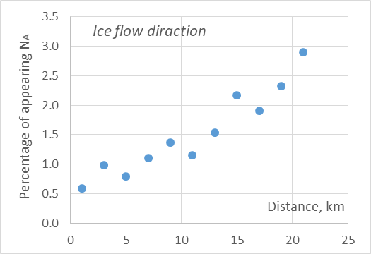
Figure 2. The percentage of anomalous data occurrence at different parts of the glacier

Figure 2 clearly shows an increasing number of anomalous cases toward the glacier terminus. This tendency may be related to the increasing influence of the marine environment as the reference points approach the coast, which can introduce additional uncertainties into the reanalysis data.
Table 1 also presents the percentage of anomalous cases for each reference point and each year of the observation period. Figure 3 illustrates the temporal variation in the occurrence of these cases over the 2015–2022 observation period.
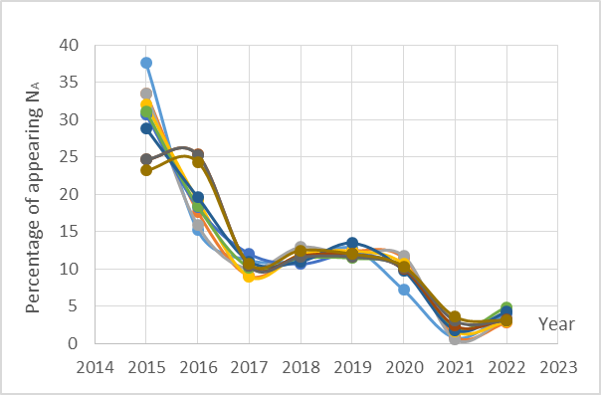
Figure 3. The percentage of anomalous data occurrence for points P1-P12 during 2015-2022.

The graph shows that, regardless of the location of the reference point along the glacier, the number of anomalous cases decreases consistently over time. This indicates an improvement in the agreement between the reanalysis data and the observed spatial temperature patterns. The decrease can be characterized by two distinct stages. During 2015–2017, the percentage of anomalous cases decreased from approximately 25–35% to about 10%. After 2020, this value decreased further, reaching approximately 5%.

Conclusions
The analysis of the ERA5 reanalysis dataset and its comparison with in situ meteorological measurements demonstrate the potential for improving air temperature estimation over the Antarctic region using remote sensing and reanalysis data. This improvement is achieved through the integration and processing of large volumes of data obtained from different sources, including products provided by the Copernicus Programme. Satellite radar imagery provides a continuous source of observations for generating glacier velocity maps and developing predictive models of glacier dynamics in response to changes in atmospheric temperature. Ultimately, the developed predictive model can be used to estimate the amount of ice transported from the glacier into the ocean, providing an additional basis for assessing glacier mass loss and its contribution to sea-level rise.

Acknowledgements
The authors gratefully acknowledge the State Institution National Antarctic Scientific Center of Ukraine for providing access to meteorological observations from the Ukrainian Antarctic Station Akademik Vernadsky (station 89063).

References
Climate Unboxed. (2021, April 2). The Beauty of NetCDF [Video recording]. https://www.youtube.com/watch?app=desktop&v=UvNBnjiTXa0&list
Cook, A. J., Vaughan, D. G., Luckman, A. J., & Murray, T. (2014). A new Antarctic Peninsula glacier basin inventory and observed area changes since the 1940s. Antarctic Science, 26(6), 614–624. https://doi.org/10.1017/S0954102014000200
Gleixner, S., Demissie, T., & Diro, G. T. (2020). Did ERA5 Improve Temperature and Precipitation Reanalysis over East Africa? Atmosphere, 11(9). https://doi.org/10.3390/atmos11090996
Kadurin, S., & Kadurin, V. (2023). The dynamics of Trooz Glacier, Antarctic Peninsula, by satellite remote sensing data. Ukrainian Antarctic Journal, 21(2), 117–133. https://doi.org/10.33275/1727-7485.2.2023.71
Tretyak, K. R., & Kukhtar, D. V. (2023). Modeling the Trooz Glacier’s movement using air temperature data and satellite SAR observations in 2015–2022. Ukrainian Antarctic Journal, 21(1), 24–36. https://doi.org/10.33275/1727-7485.1.2023.70

