Computer prediction of biological activity of 1,2,4-triazole derivatives of 1,4-naphthoquinone
Nataliia Polish¹, Oleksii Kurylo, Andriy Karkhut, Lesya Zhurakhivska, Nataliia Marintsova
1. Department of Technology of Biologically Active Compounds, Pharmacy and Biotechnology, Lviv Polytechnic National University, S. Bandery st., 12, Lviv, 79013, Ukraine. polishn@ukr.net
Abstract – Promising directions of experimental research of 1,2,4-triazole-containing 1,4-naphthoquinone derivatives biological activity using preliminary computer prediction with the PASS Online and GUSAR programs were found.
Keywords – 1,2,4-triazole-containing derivatives of 1,4-naphthoquinone, biological activity, toxicity, PASS Online, GUSAR.

Introduction
Today, the use of computer prediction methods is an important step in the initial stage of searching for biologically active compounds. Thus, in silico methods make possible to plan experimental biological research, chemical synthesis and accelerate the search and development of new drugs.
It is known that 1,4-naphthoquinones and 1,2,4-triazole derivatives are potential biologically active compounds with a broad spectrum of action [1]. That is why research on the synthesis of compounds containing both 1,2,4-triazine or 1,2,4-triazole moiety and quinoid linkage system is of great interest, and the use of PASS Online and GUSAR programs will help to achieve the most effective results in a short period of time.

Discussion of results
The following 1,2,4-triazole-containing derivatives of 1,4-naphthoquinone were selected as research objects:
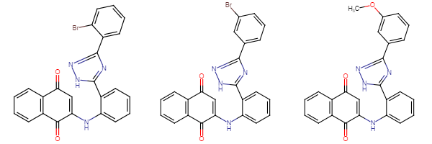
1a 1b 1c
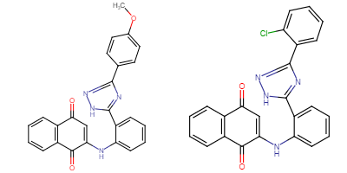
1d 1e
To plan the direction of experimental studies of the 1,2,4-triazole-containing derivatives of 1,4- naphthoquinone biological activity, we used prediction with the computer program PASS (Prediction of

Activity Spectra for Substances) [2], which provides simultaneous prediction of many types of biological activity based on the structure of organic compounds. As a result of screening, it was found that all our compounds (1a-e), with a probability of Pa> 0.7, have anticancer activity, and therefore are promising objects for further research. Also 1,2,4-triazole-containing naphthoquinone derivatives (1a-e) with a probability of Pa> 0.8 are inhibitors of histidine kinase and can be promising antimicrobial drugs.
Using the free web service (http://www.pharmaexpert.ru/GUSAR/AcuToxPredict/) we conducted acute rodent toxicity modeling QSAR, implemented in GUSAR software [3]. The LD50 value is one of the important characteristics of acute toxicity, which corresponds to a dose that causes 50% mortality within 24 hours after administration of the substance. Acute toxicity determined by external, oral or inhalation administration is an important parameter for assessing the overall toxicological risk, while acute toxicity by intraperitoneal and intravenous administration is an important parameter for drug development.
It was found that 1,2,4-triazole-containing naphthoquinone derivatives (1a-e) probably belong to low-toxic drugs (toxicity class 4, 5). Compounds (substances) 1a and 1b by the intraperitoneal route of administration proved to be probably non-toxic. The obtained results testify to the high expediency of searching for new antitumor drugs among the studied naphthoquinone derivatives (1a-e).
Table 1

Predicted acute toxicity of synthesized 1,2,4-triazine-containing 1,4-naphthoquinone derivatives to rats

Substance | Intraperitoneal route of administration |  | Intravenous route of administration |  | Oral route of administration |  | Subcutaneous route of administration
 | LD50  (mg/kg) | Classification of toxicity of  substances* | LD50  (mg/kg) | Classification of toxicity of  substances* | LD50  (mg/kg) | Classification of toxicity of  substances* | LD50  (mg/kg) | Classification of toxicity of  substances*
1a | 1536,000 | Non Toxic | 120,400 | Class 4 | 3213,000 | Class 5 | 1909,000 | Class 5
1b | 1579,000 | Non Toxic | 131,000 | Class 4 | 2783,000 | Class 5 | 2263,000 | Class 5
1c | 861,700 | Class 5 | 115,300 | Class 4 | 1664,000 | Class 4 | 1821,000 | Class 5
1d | 811,100 | Class 5 | 145,500 | Class 4 | 3306,000 | Class 5 | 1691,000 | Class 5
1e | 985,300 | Class 5 | 118,900 | Class 4 | 2579,000 | Class 5 | 1200,000 | Class 5
Note: * Classification of acute toxicity to rodents according to the OECD project (Organization for Economic Cooperation and Development).

Conclusion
Promising areas of experimental biological studies of 1,2,4-triazole-containing naphthoquinone derivatives (1a-e), based on the results of biological activity screening with use of a computer system PASS and toxicity were found.

References
- Polish, N.V., Marintsova, N.G., Karkhut, A.I., Kovalenko, S.I., Novikov, V.P. (2020). Synthesis of new 1,2,4-triazine- and 1,2,4-triazole-containing 1,4-naphthoquinone derivatives and the study of their biological activity. Voprosy Khimii i Khimicheskoi Tekhnologii, 5(132), 73-80. http://dx.doi.org/10.32434/0321-4095-2020-132-5-73-80
- Filimonov, D. A., Lagunin, A. A., Gloriozova, T. A., Rudik, A. V., Druzhilovskii, D. S., Pogodin, P. V., & Poroikov, V. V. (2014). Prediction of the biological activity spectra of organic compounds using the PASS online web resource. Chemistry of Heterocyclic Compounds, 3(50), 444-457. https://doi.org/10.1007/s10593-014-1496-1
- Lagunin, A., Zakharov, A., Filimonov, D., & Poroikov, V. (2011). QSAR modelling of rat acute toxicity on the basis of PASS prediction. Molecular informatics, 30(2-3), 241-250. https://doi.org/10.1002/minf.201000151

