Nanoparticles modification for magnetic electrospun composites for tissue engineering
Anna Hlukhaniuk^{1,2}, Małgorzata Świętek¹, Vitalii Patsula¹, Beata Zasońska², Jiří Hodan¹, Antonín Brož³, Marina Malić³, Daniel Horák¹
1. Department of Polymer Particles, Institute of Macromolecular Chemistry, Czech Academy of Sciences, CZECH REPUBLIC, Prague 162 06, Heyrovského nám. 2, E-mail: hlukhaniuk@imc.cas.cz
2. Faculty of Science, Charles University, CZECH REPUBLIC, Prague 128 00, Albertov 6
3. Institute of Physiology, Czech Academy of Sciences, CZECH REPUBLIC, Prague 142 20, Vídeňská 1083
Abstract Polymer-based magnetic composites find multiple applications in biomedicine. Good compatibility between polymer matrix and magnetic nanoparticles is an important issue assuring their uniform distribution. Herein, a series of iron oxide nanoparticles grafted with poly(ε-caprolactone) (PCL) was prepared and the effect of their composition on the properties of electrospun PCL-based composites was investigated.
Кеуwords magnetic nanoparticles, polymer composites, tissue engineering, nanoparticle grafting.
Introduction
The current rapid development of tissue engineering is made possible by advances in biology, chemistry, physics and material engineering. The ease of processing and the wide choice of polymers, which translates into the possibility of tailoring them to the specific tissue in terms of physiochemical properties, make polymers one of the most commonly used materials for tissue scaffolds [1-2]. Modification of polymeric matrix with various inorganic components allows enhancement of its mechanical properties and brings unique properties to scaffolds. For example, iron oxide-based nanoparticles (IONs), especially magnetite and maghemite, which are characterized by good magnetic properties and high biocompatibility, have been used to produce magnetic polymer-based scaffolds [3-4]. Noteworthy, a combination of magnetic polymer-based scaffolds and an external magnetic field has been reported to stimulate stem cells and bone cells to proliferate and differentiate, facilitate magnetic field-assisted drug delivery and fixation of a scaffold at the destination site, and accelerate the rate of polymer matrix degradation via magnetocaloric effect under alternating magnetic field [5-7]. Magnetic scaffolds have been also exploited in, e.g., cancer treatment by magnetic hyperthermia, targeted drug delivery systems, and diagnostics (magnetic resonance imaging and computed tomography) [4].
A key point in the design of the nanoparticles and the polymer matrix is their good chemical compatibility, which is essential to avoid possible aggregation that could negatively affect the scaffold properties [8-9]. To provide good compatibility between IONs and PCL matrix, the nanoparticles were grafted with PCL according to the novel Sipomer PAM 200 (SIPO)-mediated approach before their incorporation into the matrix. The scaffolds were prepared in the form of fibrous mats by the electrospinning technique, which is one of the most widely exploited methods used to fabricate tissue scaffolds of controllable fiber size. Due to the high surface area-to-volume ratio, electrospun mats greatly mimic the extracellular matrix, facilitating cell attachment [10].
Experimental
IONs denoted later as Fe₃O₄ were synthesized by the coprecipitation method according to the previously described procedure from aqueous solutions of iron chlorides in a Fe³⁺/Fe²⁺ molar ratio of 2:1 [11]. The particles were magnetically separated and washed with water until a stable colloidal suspension was formed. The average diameter was 10.5 nm (SD 1.9) and PDI = 1.09.
An original three-step procedure was used to prepare PCL-modified magnetic nanoparticles. First, the ION surface was modified with SIPO followed by functionalization with amino groups in the reaction with ethylenediamine (EDA) (resulting particles were denoted as Fe₃O₄@SIPO-NH₂). Then, PCL was grafted from the nanoparticle surface by ring-opening polymerization of ε-caprolactone (CL) (resulting in Fe₃O₄@PCL), which involved a reaction between the terminal hydroxyl group of CL and the amino groups exposed on the Fe₃O₄@SIPO-NH₂ surface. The particles were prepared with various CL/Fe₃O₄@SIPO-NH₂ ratios, Table 1.
Magnetic polymer composites were prepared by the electrospinning technique from the dispersion of grafted nanoparticles in PCL solution in dichloromethane/dimethylformamide (3:1 v/v). The content of Fe₃O₄@PCL was 2 wt.% relative to the total weight of the polymer. The electrospun mat made of PCL was used as a control. Composites containing magnetic nanoparticles were denoted as mPCL1-mPCL4, depending on the content of particles incorporated.
Results and Discussion
Modified nanoparticles exhibited a lower propensity to aggregate compared to non-grafted particles, Fig. 1 a-b. The presence of PCL was confirmed by ATR-FTIR spectra, Fig. 1 c, by the presence of typical bands at 1,091 and 1,451 cm⁻¹ of C-O stretching, two peaks at 1,735 and 1,652 cm⁻¹ from stretching vibrations of C=O and C=C of SIPO, respectively. Asymmetric and symmetric stretching of CH₂ in methyl and methylene bonds appeared at 2,971, 2,906, and 2,870 cm⁻¹. The specific peak of the N-H bond at 1,652 cm⁻¹ was registered for modified with SIPO and EDA nanoparticles. The amount of grafted polymer on the nanoparticles’ surface was determined by TGA, Table 1. According to obtained results, the ratio of CL/Fe₃O₄ used during modification strongly influences the amount of grafted PCL.
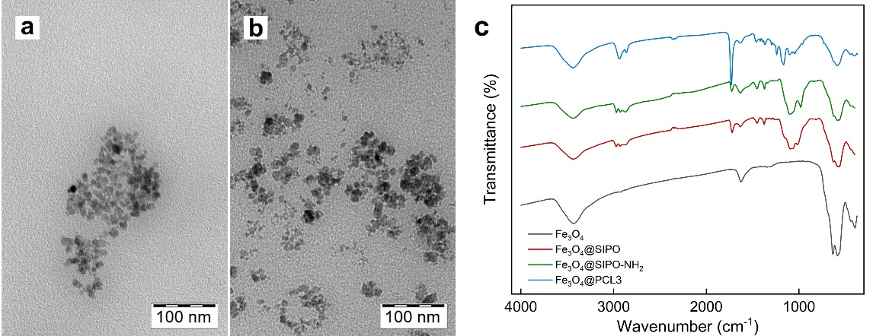
Fig. 1. TEM micrographs: (a) neat Fe₃O₄, (b) Fe₃O₄@PCL3, and (c) ATR-FTIR spectra of IONs.
Table 1.
Nanoparticles composition
Particles | Amount of Fe₃O₄ (mg) | CL/Fe₃O₄  (w/w) | Weight loss (wt.%) | Amount of grafted PCL (wt. %)
Fe₃O₄ | --------- | -------- | 4.5 | ---------
Fe₃O₄@PCL1 | 180 | 11.1/1 | 58.0 | 53.5
Fe₃O₄@PCL2 | 300 | 6.7/1 | 76.0 | 71.5
Fe₃O₄@PCL3 | 120 | 16.7/1 | 87.0 | 82.5
Fe₃O₄@PCL4 | 60 | 33.3/1 | 93.0 | 88.5

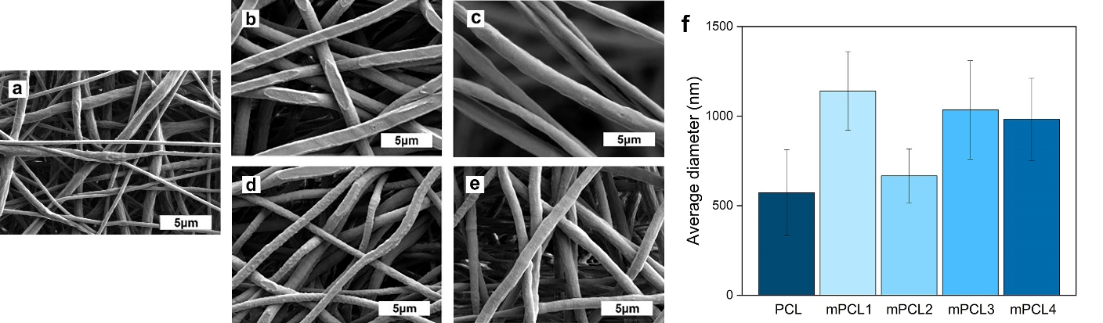
Fig. 2. SEM micrographs: (a) PCL, (b) mPCL1, (c) mPCL2, (d) mPCL3, and (e) mPCL4, and (f) average fiber diameters of PCL nanocomposites.
The morphology and fiber size of the composite mats were analyzed from micrographs. All fibers showed smooth surfaces and untangled net, Fig. 2 a-e. Measurements of changes in fiber diameter revealed that the amount of grafted polymer on nanoparticles non-proportionally affected the diameter in comparison to pure PCL, Fig. 2 f. However, the modification of PCL with IONs led to increased fiber diameter in all samples. The mechanical tests of all composites showed changes in tensile strength and Young’s modulus, Table 2. Composites with lower diameters of PCL and mPCL2 were stiffer due to higher Young’s modulus and smaller diameter fibers. Also, the introduction of particles into the polymer matrix led to a slight decrease of the water contact angle, Table 2.
Table 2
Fiber composites characterization
Denotation | Tensile strength (MPa) | Young’s modulus (MPa) | Water contact angle  (º)
PCL | 7.9±0.8 | 25.9±1.9 | 139
mPCL1 | 5.7±0.4 | 16.6±1.4 | 136
mPCL2 | 11.9±0.8 | 28.5±1.8 | 127
mPCL3 | 10.3±0.6 | 22.4±2.2 | 135
mPCL4 | 3.6±0.3 | 16.9±1.6 | 136

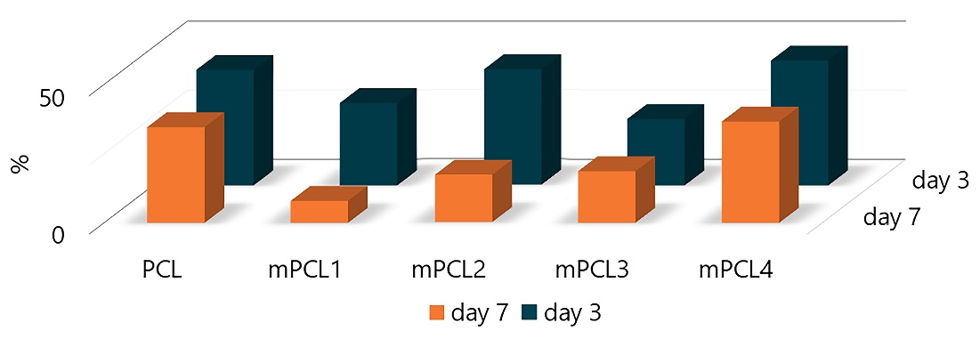
Fig. 3. Metabolic activity of SAOS-2 cells cultivated on PCL composites.
SAOS-2 osteosarcoma cells were cultivated on polymer mats for 3 and 7 days to assess the biological properties of the materials in terms of cellular metabolic activity, Fig. 3. The comparable metabolic activity on PCL and mPCL4 mats significantly differed from results on mPCL1 and mPCL4 indicating that both morphology of composites and particle composition influenced the cellular response.
Conclusions
The proposed three-step surface modification of magnetic nanoparticles via grafting of PCL from the surface allows solving the problem of particle low stability in polymer matrix when producing scaffolds for tissue engineering. The described procedure improved the stability and uniform distribution of nanoparticles within the matrix of a hydrophobic polymer and affected the morphology and mechanical properties of electrospun nanofibers in a grafting-dependent manner. Moreover, the changes in metabolic activity of SAOS-2 osteosarcoma cells were registered. Composites with particles having 53 wt.% of grafted PCL induced the formation of thick fibers, however, with low mechanical properties and decreased toxicity. In contrast, particles containing 71 wt.% of IONs resulted in the formation of composites with the narrowest fibers and enhanced mechanical properties but high toxicity. The results are valuable for further development of multifunctional scaffolds for biomedical applications.
Acknowledgments
The study was supported by the Czech Science Foundation (No. 20-07015S).
References
[1] Zhang, J., et al. (2014). 3D-printed magnetic Fe₃O₄/MBG/PCL composite scaffolds with multifunctionality of bone regeneration, local anticancer drug delivery and hyperthermia. J. Mater. Chem. B 2. DOI: 10.1039/C4TB01063A
[2] Farzin, A., et al. (2017). Multifunctional magnetic nanostructured hardystonite scaffold for hyperthermia, drug delivery and tissue engineering applications. Mater. Sci. Eng. C 70, 21–31. DOI: 10.1016/j.msec.2016.08.060
[3] Świętek, M., et al. (2019). Mater Sci Eng C 104, 109913. DOI: 10.1016/j.msec.2019.109913
[4] Liu, Q., et al. (2020). Ultrasmall superparamagnetic iron oxide labeled silk Fibroin/hydroxyapatite multifunctional scaffold loaded with bone marrow-derived mesenchymal stem cells for bone regeneration. Front. Bioeng. Biotechnol. 8, 697. DOI: 10.3389/fbioe.2020.00697
[5] Eivazzadeh-Keihan, R. et al. (2020). Metal-based nanoparticles for bone tissue engineering. J. Tissue Eng. Regen. Med. 14, 1687–1714. DOI: 10.1002/term.3131
[6] Xia, Y. et al. (2018). Magnetic field and nano-scaffolds with stem cells to enhance bone regeneration. Biomaterials 183, 151–170. DOI: 10.1016/j.biomaterials.2018.08.040
[7] Yun, H. M. et al. (2016). Magnetic nanocomposite scaffolds combined with static magnetic field in the stimulation of osteoblastic differentiation and bone formation. Biomaterials 85, 88–98. DOI: 10.1016/j.biomaterials.2016.01.035
[8] Zare, Y., et al. (2016). Study of nanoparticles aggregation/agglomeration in polymer particulate nanocomposites by mechanical properties. Compos. Part A Appl. 84, 158–164. DOI: 10.1016/j.compositesa.2016.01.020
[9] Liu, J., et al. (2011). Nanoparticle dispersion and aggregation in polymer nanocomposites: Insights from molecular dynamics simulation. Langmuir 27(12), 7926–7933. DOI: 10.1021/la201073m
[10] Jun, I., et al. (2018). Electrospun fibrous scaffolds for tissue engineering: Viewpoints on architecture and Fabrication. Int. J. Mol. Sci. 19(3), 745. DOI: 10.3390/ijms19030745

