Study of Сhanges in Acid-Alkaline Balance of Cooling Water Сirculating System of Power Plants during Water Treatment by Liming According to Stabilization Treatment Method

Pavlo Kuznietsov, Olga Biedunkova
National Unsversity of Water and Environmental Engineering, Ukraine, Rivne, Soborna Street, 11, E-mail: kuznetpavel@gmail.com.com
Abstract The article presents research results on carbonate system components of cooling water, which has previously undergone water treatment by liming, depends on the cycle of concentration and absorption of carbon dioxide, which simulate the processes of evaporation and aeration in circulation cooling systems (СCS) of power plants.
Кеуwords circulating cooling systems, cooling water, power plants, carbon dioxide, bicarbonate, carbonate ions, pH.
Introduction
The ratio of carbon dioxide, bicarbonate and carbonate ions is the main indicator that determines pH (Cole & Prairie, 2014, p. 30). Each form exists in a certain pH interval, the presence of one or another form in the carbonate system components determines one or another value of water pH, that stipulates the coexisting forms of carbonate system components. Dissolved сarbon dioxide interacts with water and forms bicarbonate and carbonate ions, аn increase of pН in water as an important component of carbonate-calcium equilibrium leads to its shift towards the formation of calcium carbonate (Stets et al., 2017, p. 663).
Lighting by liming is one of the most common methods of water treatment (Khoruzhyi et al., 2017, p. 534). Research object is the carbonate system of technological and circulation water of Rivne NPP. Water treatment includes liming and stabilization of additional water with sulfuric acid. According to the requirements to the composition and properties of water bodies of drinking water points, recreation areas, as well as fishing reservoirs, the pH should not go beyond the range of values of 6.5-8.5. The measuring method pH index in surface, underground, circulating water is regulated by (MVI 081/12-0317-06, 2006).
Treatment with sulphuric acid of additional cooling water is carried out during regulation of 7.5-7.8 pH. The impact of air aeration on the cooling water in cooling towers was modeled in laboratory conditions was reproduced on the test bench.
Research results
The dynamics of pH changes during the concentration and aeration of cooling water samples with and without stabilization treatment by sulphuric acid are shown in Fig. 1-3. As can be seen from the data of Fig. 1, when concentrating cooling water, which is not neutralized by sulphuric acid, there is an reduction of pH with a carbonate system component change caused by scale formation with the formation of calcium carbonate. For a sample treated by sulphuric acid (Fig. 1) an increase of pH is observed and is caused by the decomposition of bicarbonates, which is also accompanied by calcium carbonate formation.
As can be seen from the data in Fig. 2, during air aeration through cooling water samples without sulphuric acid, absorption of carbon dioxide is observed, pH decreases to values of 8.3-8.5. During this process carbonates are neutralized and equilibrium of the carbonate system is shifted with the accumulation of bicarbonates. Fig. 3 shows that for cooling water samples with sulphuric acid treatment during aeration pH increases to values of 8.3-8.6 due to the absorption of carbon dioxide with the accumulation of bicarbonates.
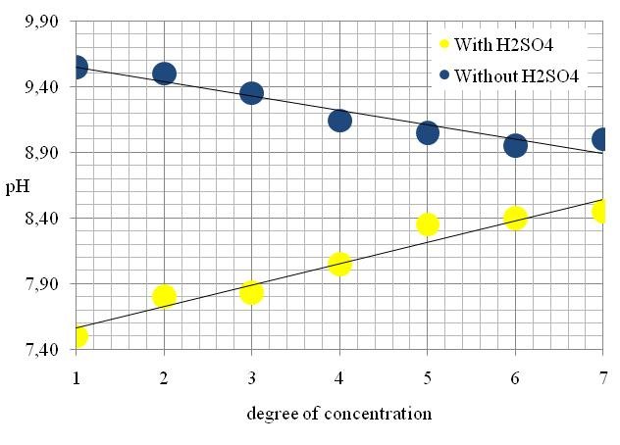
Fig. 1. Dynamics of pH sample changes depending on concentration of cooling water with/without sulphuric acid
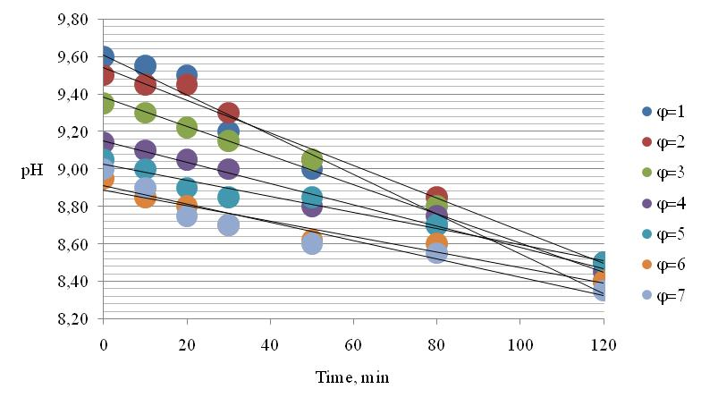
Fig. 2. pH change of cooling water samples during aeration without sulphuric acid treatment at different evaporation coefficients
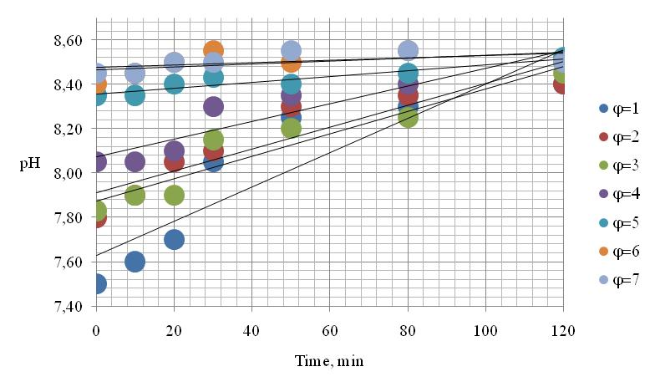
Fig. 3. pH change of cooling water samples during aeration with sulphuric acid treatment at different evaporation coefficients
As can be seen from the data in Table 1, during stabilization treatment with sulfuric acid, the value of the difference ϕ - ψ is smaller, accordingly, the scale formation intensity is also smaller and preservation of proportionality of changes in coefficients ϕ and ψ. Normalized coefficient differences ϕ - ψ < 0.2, without the use of sulfuric acid, are provided at ϕ=3 and less, and when treated with sulfuric acid at ϕ=4 and less. This determines the expediency of using sulfuric acid to inhibit the formation of scale only when working at higher evaporation rates.
Table 1.
The value evaporation coefficients in coefficients φ and ψ for samples of cooling water after evaporation and aeration without/with stabilization treatment H₂SO₄
Evaporation coefficients  ϕ | Without stabilization treatment H₂SO₄* |  | With stabilization treatment H₂SO₄*
 | Concentration of chloride ions ± Δ, ppm | Scale formation indicator  (ϕ - ψ) ± Δ | Concentration of chloride ions ± Δ, ppm | Scale formation indicator  (ϕ - ψ) ± Δ
1 | 10,5 ± 1,1 | - | 10,5 ± 1,1 | -
2 | 20,3 ± 2,0 | 0,07 ± 0,01 | 19,8 ± 2,0 | 0,05 ± 0,01
3 | 30,1 ± 1,5 | 0,15 ± 0,02 | 31,1 ± 1,6 | 0,08 ± 0,01
4 | 39,5 ± 2,0 | 0,29 ± 0,03 | 40,4 ± 2,0 | 0,14 ± 0,01
5 | 51,3 ± 2,6 | 0,41 ± 0,04 | 50,3 ± 2,5 | 0,28 ± 0,03
6 | 62,1 ± 3,1 | 0,74 ± 0,07 | 59,2 ± 3,0 | 0,39 ± 0,04
7 | 69,4 ± 3,5 | 1,13 ± 0,11 | 71,3 ± 3,6 | 0,62 ± 0,06
Note: * Δ – absolute measurement error
Conclusions
The equilibrium of the carbonate system components in ecosystems and technoecosystems can be achieved naturally due to the absorption of carbon dioxide from the air, concentration, precipitation of calcium carbonate. The accumulation of bicarbonate ions and the neutralization of carbonate ions from an environmental point of view does not compensate the artificial introduction of sulphate ions into natural objects to use sulphuric acid for stabilization treatment.
Taking into account the establishment of equilibrium in the carbonate system in CCS and natural water , the use of sulphuric acid for water treatment namely to ensure environmental standards for the pH value is impractical. The use of sulphuric acid can be justified to optimize the water-chemistry mode in order to reduce scale in CCS. The results of the study can be applied to any power plant with CCS, where water treatment of cooling water by liming is implemented.
References
[1] Cole, J. J, & Prairie, Y. T. (2014). Dissolved CO2 in Freshwater Systems. Reference Module in Earth Systems and Environmental Sciences, 17, 30-34. https://doi.org/10.1016/B978-0-12-409548-9.09399-4
[2] Stets, E., Butman, D,, McDonald, C. P., Stackpoole S., M., Michael D., D., Striegl R., G. (2017) Carbonate buffering and metabolic controls on carbon dioxide in rivers. Global Biogeochemical Cycles, 31, 663-677. https://doi.org/10.1002/2016GB005578
[3] Khoruzhyi, P. D., Khomutetska, T.P., Khoruzhyi, V.P. (2008) Resource-saving technologies of water supply Agrarian Science, 2, 154-161. https://doi.org/10.31073/mivg202002-242
[4] MVI 081/12-0317-06 Surface, underground, recirculation water. The method of measuring the pH indicator (pH) by the electrometric method, standart in Ukranian, 2006.

